OOAD LAB EXPRIMENT

Draw the UML Diagrams for Online Internship Registration System and generate the Skeleton Code accordingly

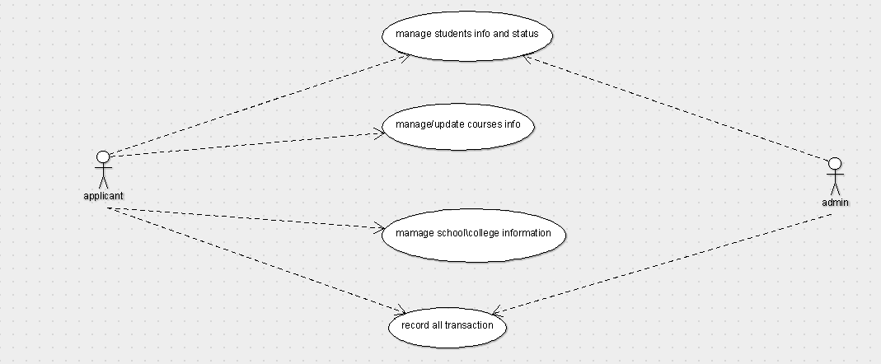

USE-CASE DIAGRAM

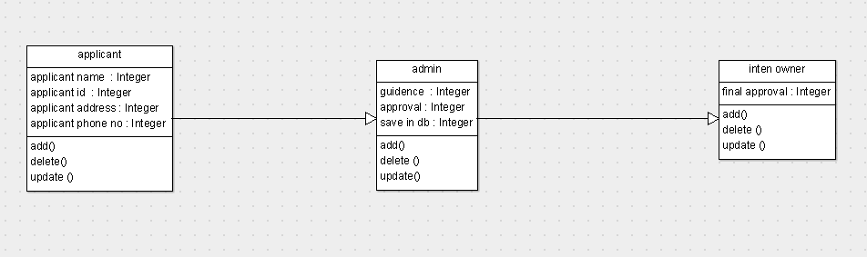

CLASS DIAGRAM

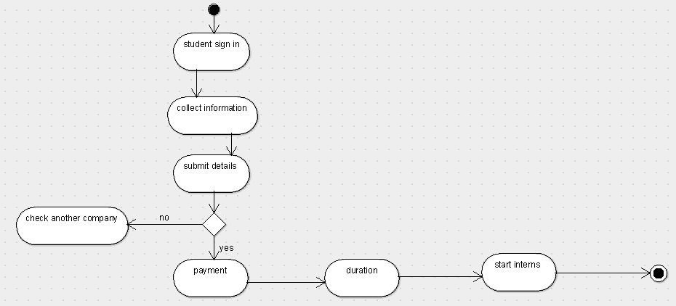

ACTIVITY DIAGRAM

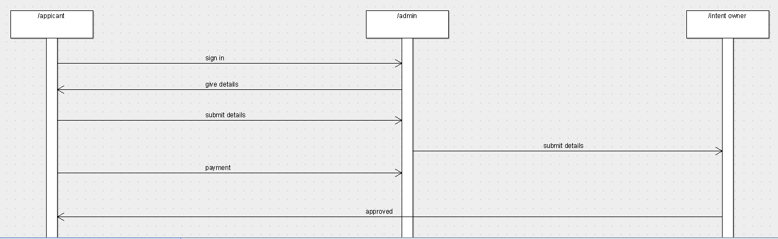

SEQUENCE DIAGRAM

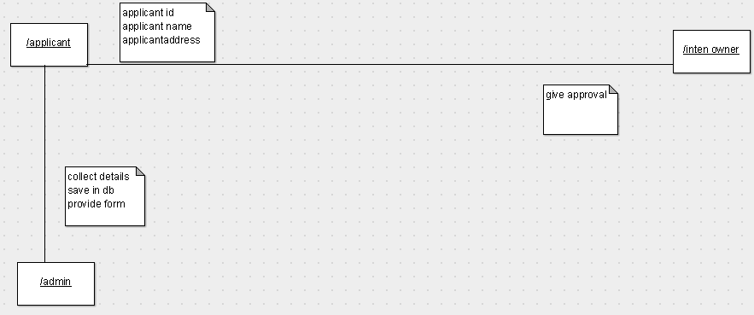

COLLABORATION DIAGRAM

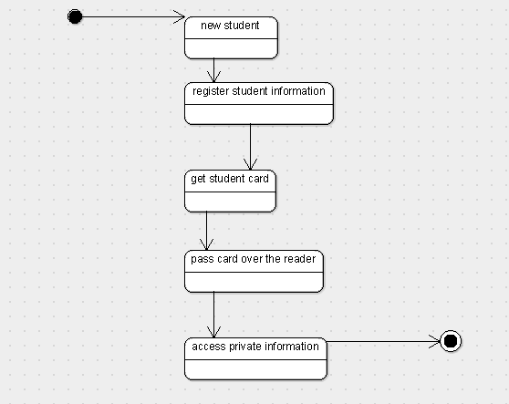

STATE CHART DIAGRAM

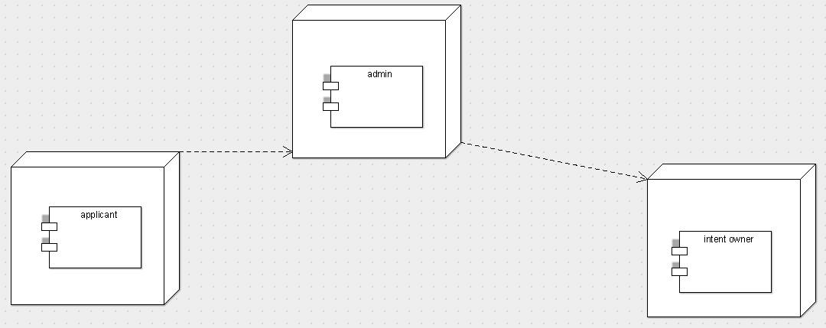

COMPONENT DIAGRAM

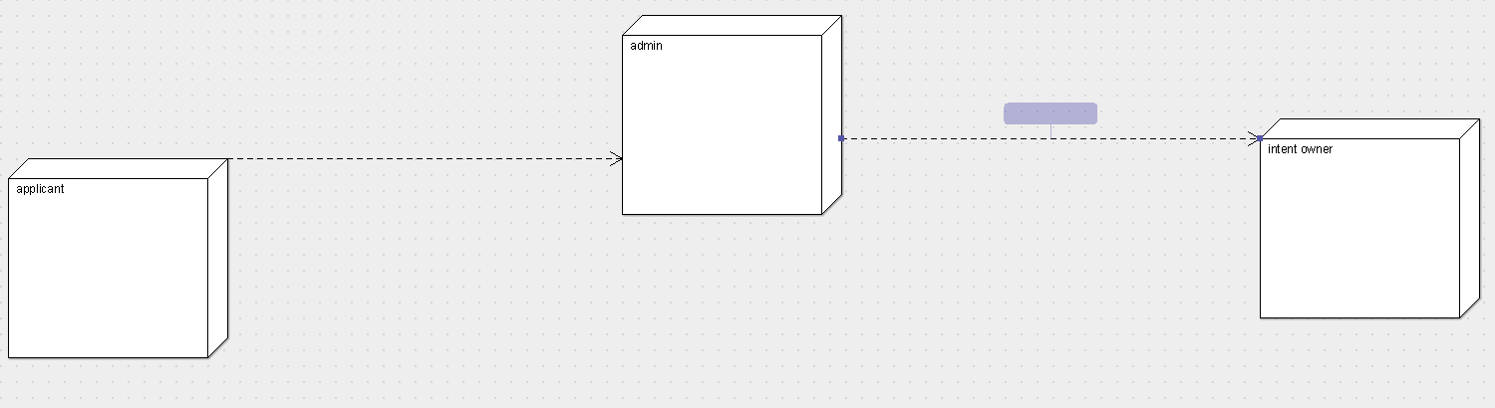

DEPLOYMENT DIAGRAM

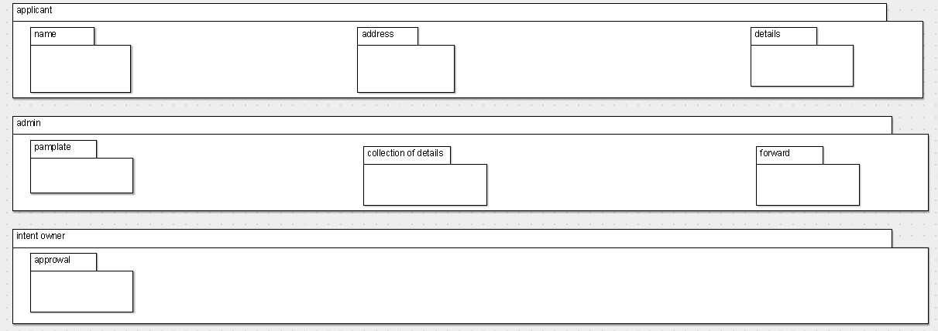

PACKAGE DIAGRAM